

EVERPURE

Hanan Shahade (20240187)
Jad Al Hajjar (20240244)
Dania Chamly (20240363)
Rand Al Yaman (20240078)
Anthony Abo Merhi (20220568)
BMKA200 Fall2025 – Section 2
Dr. Maya Daher
November 27, 2025

Table of Contents

1. Introduction 4
2. Market Research and Insights 4
Problem: 4
Solution: 5
3. SWOT Analysis 5
3.1. Strength: 5
3.2. Weaknesses: 5
3.3. Opportunities: 5
3.4. Threats: 6
4. Product Analysis 6
4.1. Key Features 6
4.2. Benefits 6
4.3. Branding 7
4.4. Innovation 7
4.5. Packaging 7
4.6. Positioning 7
5. Pricing Strategy 8
5.1. Price point 8
5.2. Why does penetration fit EverPure? 8
5.3. Competitor price comparison 8
6. Place (Distribution Strategy) 9
Distribution Channels 9
7. Promotion Strategy 9
8. Conclusion & Future Recommendations 12
9. References 13

Introduction
EverPure - a new product made to ensure safe drinking water- has a filter that clears the doubts of Lebanese people regarding the safety of the water they drink daily. As the problem of contaminated water grows, our bottle offers a simple solution by enabling users to have control over the quality of their own water, no matter if they are at home, in the office, or out in nature. This demand and need for healthier, dependable, and eco-friendly water solutions created the idea of this product line that fits well with the current market demands.

Market Research and Insights

Problem:
Market research shows that many consumers in Lebanon have lost trust in bottled water brands after several cases of contaminated or unfiltered water were exposed.
For example, not long ago, Tannourine was exposed with reports that show contaminated water.
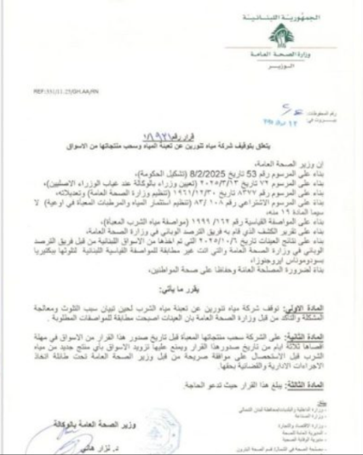
Figure 1: Ministry's Decision
(Figure1) shows the decision of the Ministry of Health regarding the contamination and dangerous water.
Tannourine is not the only case. In 2025, two water plants in Saida shut down due to bacterial contamination. In addition, many of the unlicensed water-filling stations have been closed down by authorities after going through inspection. (MTV Lebanon, 2025)

Solution:
EverPure solves this problem by guaranteeing its water quality. Through its built-in purification system, users can now enjoy their water without worrying about whether it is contaminated or not. This solution is also eco-friendly because it is reusable, which helps reduce plastic waste. It ensures customer satisfaction because of its convenience and sustainability.

SWOT Analysis

Strength:
EverPure provides clean, safe drinking water anytime. This allows consumers to control the quality of the water they drink. The bottle is also reusable, decreasing plastic waste and saving money compared to buying bottled water all the time. The portable design is convenient for daily use, whether you are at school, work, or traveling. This feature appeals to a wide range of consumers.

Weaknesses:
The higher cost compared to regular bottled water might make some potential customers think twice. Also, the consumer will need to replace the filter regularly, which adds to the long-term cost. Since it is new to the market, consumers might also need time to fully trust it.

Opportunities:
With more Lebanese consumers seeking safe and eco-friendly options, our product is very relevant. There is also a chance to partner with schools, gyms, offices, or NGOs that support health and sustainability. Furthermore, when it comes to becoming a worldwide business, EverPure has great potential as it can benefit other countries suffering from similar water problems.

Threats:
A threat could be competition from similar products or well-known bottled water brands. Lebanon’s economic challenges may also affect consumers’ ability to spend money on new products. There is a chance of copycats or low-quality imitation products showing up in the market. But changes in government regulations on water quality or filtration devices impact how the product is made or sold.

Product Analysis

Key Features
We integrated a built-in filter that purifies the water by removing chlorine, impurities, and odors.
We also created it to be Eco-friendly, as it can be recycled and used for a long period, replacing single-use plastic.
The filter is easily inserted and has a lifespan of 2 months.
Available in 3 different colors (Black, Blue, Purple) to satisfy customers’ preferences.

Benefits
Ensure water purity, providing filtered drinking water even from any tap source.
Offer an affordable long-term hydration solution because the consumer will not have to purchase daily bottled water.
Reduce the use of plastic waste.
Suitable for different activities, like the gym, work, school, etc.

Branding
Brand name: Ever Pure
Identity: eco-friendly, safe, and modern brand.
Brand Personality: clean, natural, trustworthy, and practical.

Innovation
EverPure was developed strategically to focus on sustainability and utilize long-lasting materials. This will meet the demand for accessible, affordable, and portable clean water solutions.

Packaging
It is made from simple cardboard that has the EverPure logo and QR code. Moreover, inside there are instructions for filter use and replacement.
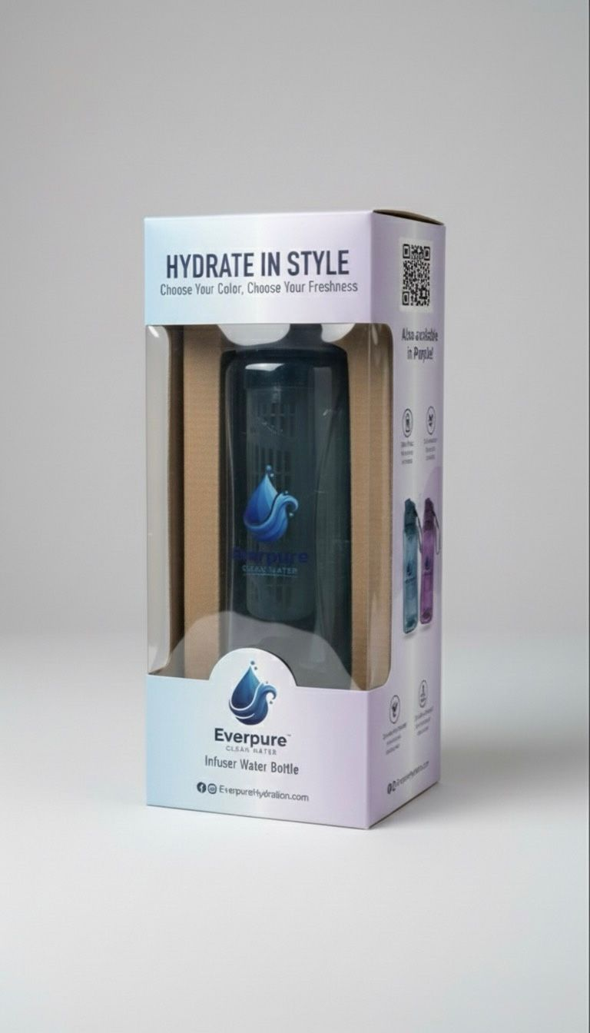
Figure 2: package

Positioning
EverPure is a stylish, eco-friendly water bottle for people who are responsible about their health, offering safe, pure water with convenience and sustainability in mind.

Pricing Strategy
EverPure will be using a penetration pricing strategy, which means that it will be launched having relatively low and competitive price to attract customers and encourage them to try it. As a new brand entering the market, EverPure introducing by an affordable price will help build awareness, gain trust grow adoption among students, athletes, and active persons.
  - Price point:
- EverPure filter bottle: $18-$20
- Replacement filter: $4-$5
This pricing is attractive to people to change from regular bottles with no features or the overpriced bottles.

Why does penetration fit EverPure?
- Price-sensitive consumers especially students and young adults who have limited wages (our target market)
- Starting with a high price could discourage users since the product is not technologically complex, yet its useful and eco-friendly.
- A lower price boosts EverPure to gain market share faster, building loyalty and to create the word-of-mouth marketing before adjusting prices gradually in the future.

Competitor price comparison
brand/product | Features | Price | Comparison
Brita filter bottle | Plastic, basic filter | $20-$25 | Similar range, EverPure offers eco-friendly material at lower/similar price
LifeStraw Go | High-end filter | $35-$40 | EverPure delivers lower price to attract users
Hydracy/Generic bottles | No filter | $10-$15 | Cheaper, but lacks the filtration feature that EverPure offers.

Place (Distribution Strategy)

Distribution Channels
- Retail Stores: Supermarkets (Spinneys, Carrefour), sports shops (Decathlon, Mike Sport), eco-shops.
- Online: EverPure website, Instagram Shop, Amazon, local Lebanese e-commerce platforms (e.g., Toters Market, LebMarket).
- Direct Sales: University booths, gym partnerships, nutrition stores.
- Third-Party Distributors: Outdoor activity shops, camping stores, pharmacies.
- Shipping over the Middle East: collaborating with Aramex and other shipping companies to deliver our product to the largest number of customers outside Lebanon.

Promotion Strategy
Print Ads: Posters in universities, gyms, cafes, supermarkets, and on the streets.
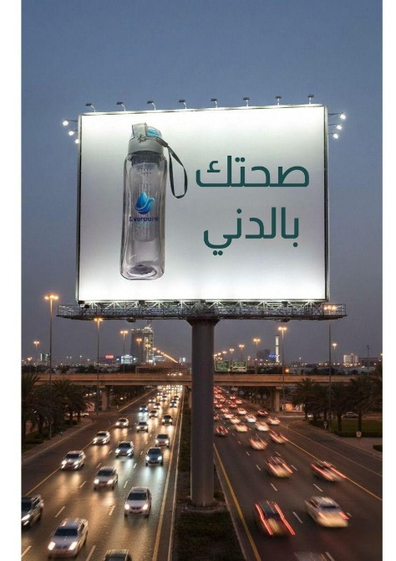
Figure 3: poster 1
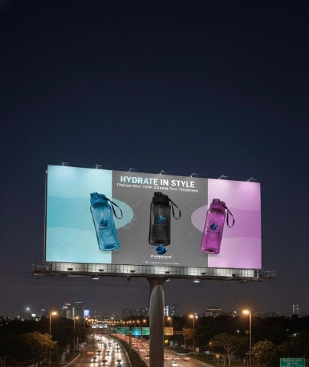
Figure 4: Poster 2
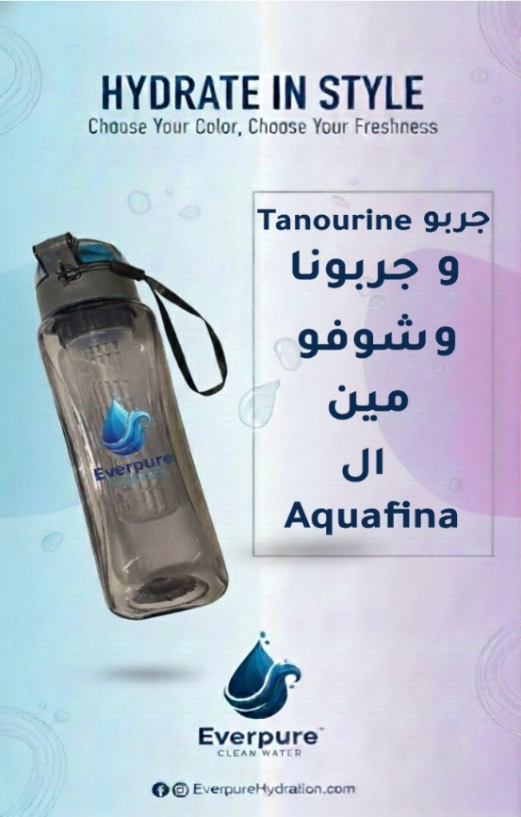
Figure 5: Poster 3
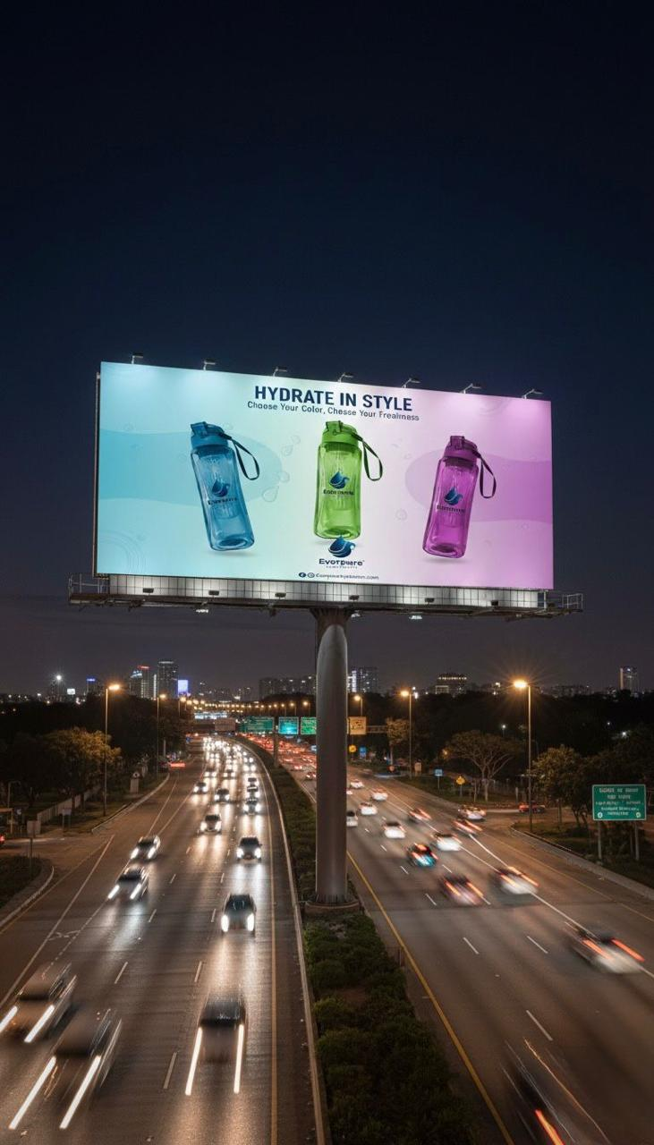
Figure 6: Poster 4
Social Media: Instagram posts, TikTok, Snapchat…
Ads: Video that will be played on the PPT.
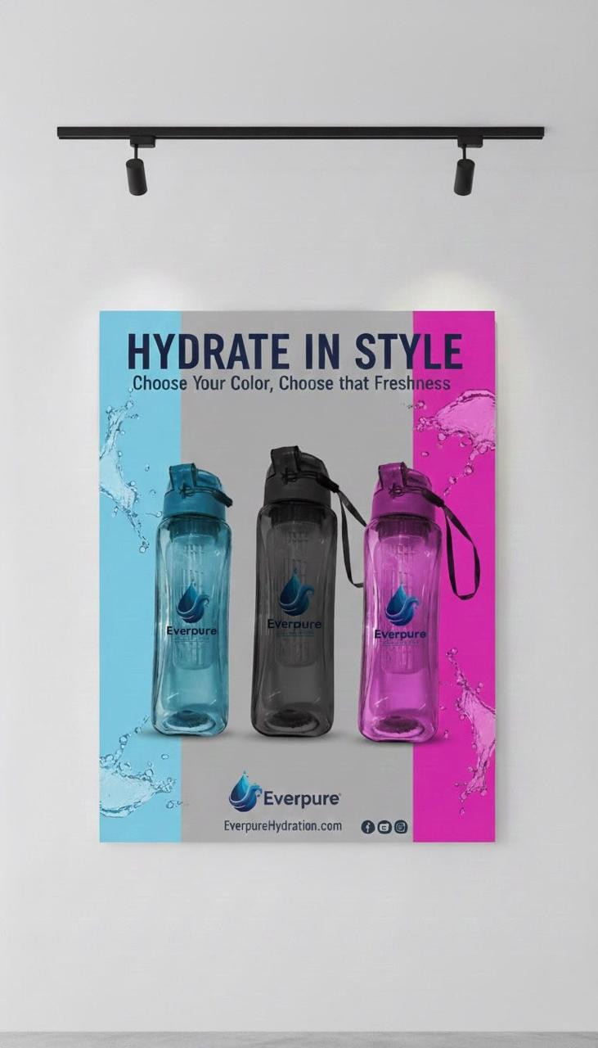
Figure 7: Instagram Post

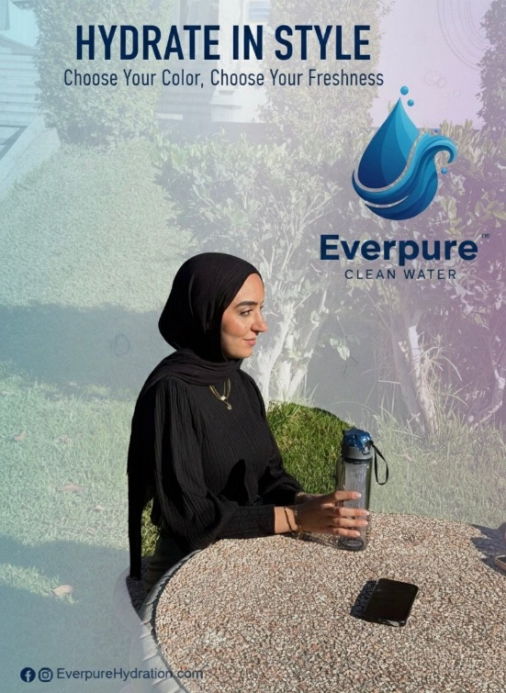
Figure 8: Another Instagram Post
Sampling Campaigns: Offer free filtered water stations at events to allow people to try EverPure.
"Everyone can now enjoy water the way it should be—clean, fresh, and effortlessly filtered in every sip thanks to EverPure."

Figure 9: people trying everpure
Testimonial Videos: The consumer feedback video will be presented during the presentation.

Conclusion & Future Recommendations
In conclusion, EverPure empowers consumers to control the quality of the water they drink. This product removes all suspicions of drinking contaminated water from the mind of the consumer and the guilt of using plastic bottles daily.
EverPure does not just offer a product. It offers a healthier, smarter, and more responsible way to live.
For future recommendations, we would like to introduce it to different market segments, like a bottle for kids, and make a stainless steel version. Also, we would make different sizes (small, large, gallons…). Moreover, we can advance the filter to have a longer lifespan.

References
((2025), October 13). Retrieved from https://www.beirut.com/en/763476/tannourine-water-pulled-from-shelves-after-dangerous-bacteria-found/
MTV Lebanon. (2025, July 25). Retrieved from MTV Lebanon: https://www.mtv.com.lb/en/news/Local/1597797/watch--bacterial-contamination-forces-closure-of-two-water-plants-in-sidon

